Act Report

**Insight 1:**

Puppo stage dogs are most popular among rater and audience, while pupper stage dogs are the least popular.

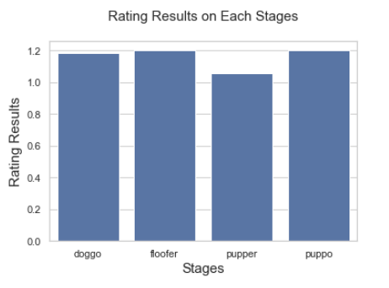

This bar plot represent the average rating result of each dog stages. We can see floofer and puppo stage were given the best average result, while pupper stage was given much lower rating.

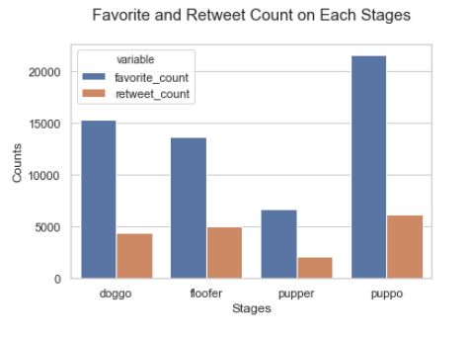

This bar plot represents average favorite count and retweet count of each tweet based on their dog stages. Clearly the tweets with puppo stage dogs were favorited and retweeted the most, while the ones with pupper stage dogs were favorited and retweeted the least.

**Insight 2:**

The saluki breed is the most popular breed by both raters and audience

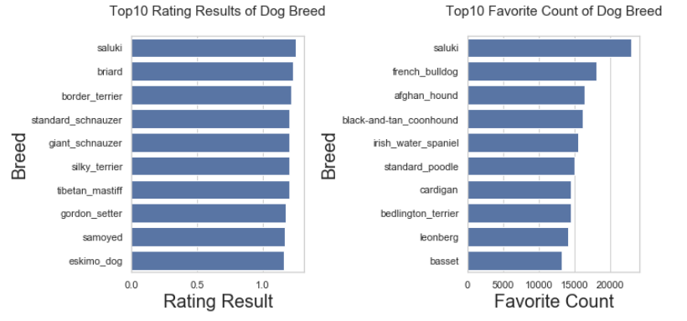

These two bar plots represents the top 10 rating results and favorite counts of dog breed. From the plots we can clearly see breed saluki receives the best rating result from the raters and highest favorite count from the audience. As a result, we can say saluki breed is the most popular breed among all dog breeds.

**Insight 3:**

Single dog pictures score higher

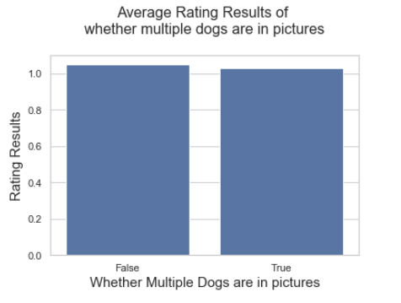

This bar plot represents the average rating results of tweets based on whether multiple dogs are in the pictures. It appears the raters tend to give higher rating to pictures with single dog compare to pictures with multiple dogs.

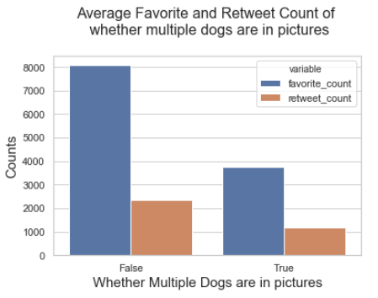

This bar plot represents the average favorite and retweet count of tweets based on whether whether multiple dogs are in the pictures. It clearly indicates that pictures with single dog are significantly more popular among audience.

**Limitations:**

* Some of the group sizes are small compared to the whole sample

The saluki breed only have 4 samples

There are only 13 pictures with multiple dogs in it.

* The breed tag of each tweet was predited by a neural network, the accuracy of the predition affects the result of the analysis derived from the breed
* The stage tag only cover a small portion of all the samples. Over 85% of tweets don't have a stage tag, which make analysis based on dog stage less conclusive.